Creating a Network Graph from the Linear A Tablets

https://lineara.xyz/network/

https://github.com/mwenge/lineara.xyz/tree/master/network/transactions

Robert Hogan October 2022

The Linear A tablets found in Haghia Triada, Khania, Zakros and elsewhere are generally considered to reflect socio-economic activity in the settlements in which they were found. Schoep[1] has previously proposed that the tablets represent a preliminary stage in information gathering by palace officials that ultimately resulted in economic records recorded on sealed papyrus documents. The portable form factor, and evidence of erasure and re-use, suggests that the use of the documents may have been stenographic in nature and that rather act as a permanent record in their own right the information contained by the tablets was later collated elsewhere.

There are many possible activities the tablets could record in an administrative context. Nearly all the tablets, regardless of find site, are concerned with the recording of quantities of commodities. The identification of specific items such as wine, oil, grain and other products in the tablets runs along a spectrum of wide consensus to tentative speculation. What is less clear, and can generally only be reconstructed hypothetically from the internal structure of the tablets themsleves, is the nature of the transactions the listed commodities were involved in. What we set out to do here is identify common patterns in the structure of the tablets and assign a hypothetical transaction type associated with each pattern, usually involving the movement of goods between two or more entities. We then use this classification to create a network graph that visualizes the movement of goods between the entities across all classifiable tablets in the Linear A corpus. We consider our attempt at classification as provisional.

## 1. Classifying the Tablets

In order to construct a network map from the Linear A tablets we must first develop a basis on which to recognize transactions between entities. To do this we take an approach similar to the classifications of the tablets developed by Palmer[2] and Schoep[3] but with an emphasis on identifying entities as well as commodities in the tablets and proposing classes of transactional relationships reflected by consistent syntactical patterns in the tablets.

Our analysis identifies basic syntactical units that can be used independently but are also composable with other units to construct records of specific transaction type. We find evidence that these constructions appear across a number of tablets across a number of different find sites.

***Entity Lists and Commodity Lists***

The most basic syntactical pattern we find in the tablets is a list of entities (an ‘Entity List’) or commodities (a ‘Commodity List’). This is found in all the tablets we are discussing here but there are some that consist solely of lists of entities or commodities. In most cases such ‘Entity List’ tablets record whole numbers against the entities, so for the purposes of our network map we interpret them as involving a transaction regarding the movement or allocation of people between the administrative centre and the named entity.

|  |  |  |  |
| --- | --- | --- | --- |
| **Tablet Reading** | | **Pattern** | |
| ME-KI-DI | 1 | | Entity List |
| *21F-*118 | 1 | |
| PU-NI-KA-*363 | 3 | |
| QA-TI-JU | 8 | |
| KU-PI | 1 | |
| TU-MI-TI-ZA-SE | 45[ | |
| PA-NU-QE | 2 | |
| JA-WI[ | [ | |

Table 1: ZA14 – a simple entity list.

There are a reasonably large number of such entity lists, mostly in a fragmentary state: HT108, HT146, HT25a, HT29, HT3, HT39, HT63, HT98a, HT99b, PE2, ZA10a, ZA14, ZA20, ZA4a, ZA5b, ZA7a. There is a disproportionately high incidence of them from Zakros compared to Haghia Triada given the relative number of tablets found at each site.

It is less obvious how to treat tablet transactions that consist solely of lists of commodities (“Commodity Lists”). There are however no clear examples of a tablet containing only a commodity list. Of the 4 we classify as such two are in a fragmentary state (HT24b, HT127b) and may be related to a transaction described on the obverse of the tablet. HT130 is largely erased and contains an isolated commodity list of CYP, NI, and VIN at its end separated from the rest of the tablet by a dividing line. This feature listing the same commodities in the same order is also found on HT27a and HT89 (and possibly on the damaged HT110a). It’s not clear what the function of this formula is in relation to the rest of the tablet each appears on but it is our only evidence of isolated commodity lists having a specific use on the Linear A tablets.

***Transfer List***

Commodity lists are by far most common, not on their own, but as part of a larger syntactical structure we term a ‘Transfer List’. A ‘Transfer List’ simply consists of a ‘Commodity List’ as we’ve defined it above but preceded by a named Entity. There are often multiple instances of this Transfer List structure on a single tablet. A common feature of these lists is that the entity is coupled with a ‘transaction sign’ that may indicate to the scribe some additional feature of the transaction. For the purposes of constructing our network map our working hypothesis is that Transfer Lists are recording a transaction in the listed commodities between the relevant administrative centre and the entity named in the list.

|  |  |  |  |
| --- | --- | --- | --- |
| **Tablet Reading** | | **Pattern Level 1** | **Pattern Level 2** |
| KI-RI-TA₂ |  | Entity | Transfer List |
| OLE+QE+DI | 10 | Commodity List |
| SA-RA₂ |  | Entity | Transfer List |
| GRA | 5 | Commodity List |
| OLE | 4 |
| NI | 2 |
| VIN | 3 |
| *23M | 3 |

Table 2: HT121 – two transfer lists from the Haghia Triada adminstrative centre. One of a quantity of oil product to KI-RI-TA2 and another of mixed commoditiest to SA-RA2.

|  |  |  |  |  |
| --- | --- | --- | --- | --- |
| **Tablet Reading** | | **Pattern Level 1** | | **Pattern Level 2** |
| A-DU |  | Entity | Transfer List | |
| [ 𐄁 ]ZA |  | Transaction Sign |
| CYP | ¹⁄₁₆ | Commodity List |
| SU | 3 |
| CYP+E | 𐝇𐝉 |
| VIN | ≈ ¹⁄₆ |
| *306 | 4 |
| CYP | ¹⁄₃ |
| *348-CYP | 𐝇𐝉 |
| A-TO-*349-TO-I |  | Entity | Transfer List | |
| CYP+E | 3 | Commodity List |
| NI | 1 |
| VIN | 3 |
| A-TA-*350 |  | Entity | Transfer List | |
| *301 | 1 | Commodity List |
| *306 | 1 |
| SI-CYP | 𐝇𐝉 |  |

Table 3: KH11 – three transfer lists from the Kharnia administrative centre, each of mixed commodities to A-DU, A-TO-*349-TO-I, and A-TA-*350 respectively.

A potential member of this group is KH5, perhaps recording the same transfer to multiple entities: the same quantities of CYP+E and VINb+WI with each of A-DA-KI-SA-KA, A-RA-U-DA, and WI-SA-SA-NE-E. The rest of the tablet could then consist of two Transfer Lists, one of an unspecified quantity of *301-NA with WI-NA-DU, and quantities of CYP and NI to KU-RA-ZU.

The tablets we classify in this group are: ARKH3a, ARKH3b, ARKH5, HT100, HT101, HT105, HT106, HT108, HT116b, HT12, HT121, HT123+124a, HT125a, HT125b, HT129, HT131a, HT131b, HT132, HT133, HT14, HT18, HT2, HT21, HT23a, HT23b, HT24a, HT27b, HT30, HT32, HT36, HT40, HT42+59, HT44a, HT58, HT91, HT92, HT94a, KH11, KH4, KH7a, KH7b, KH9, KNZb35, TY3a, TY3b, ZA15b, ZA1a, ZA6a, ZA6b, ZA9*.*

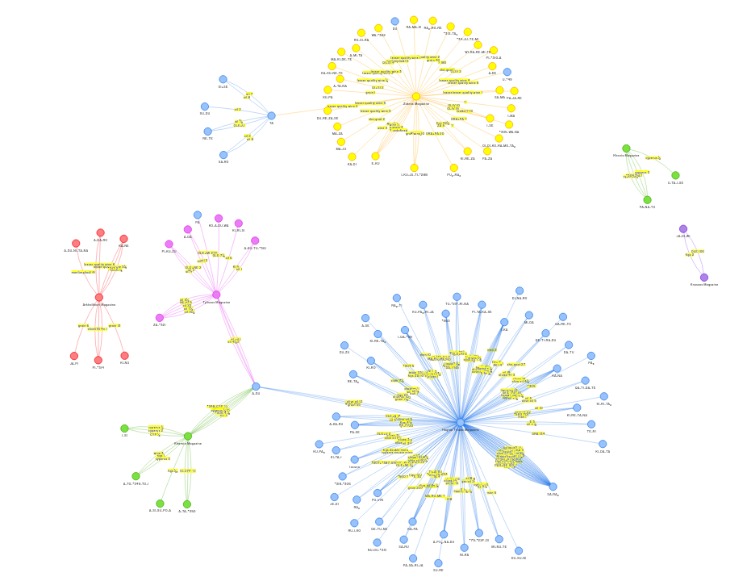Figure 1: Transfer Lists visualised. See https://lineara.xyz//network/?search=["Transfer%20List"]

***Single-Commodity Transfer List***

We find a more complex composition of a single-entry Commodity List and Entity List (together with a Named Entity and a Transaction Sign) used in a number of tablets in Haghia Triada. We propose that this structure is used to record the transfer of a single commodity to one or more entities from the administrative centre.

|  |  |  |  |
| --- | --- | --- | --- |
| **Tablet Reading** | | **Pattern Level 1** | **Pattern Level 2** |
| JE-DI |  | Entity | Single-Commodity Transfer List |
| OLE+KI | 10 | Commodity List |
| PA₃-KA-RA-TI | 1¹⁄₂ | Entity List |
| PA | 3 ¹⁄₂ |
| TE-*301 | 2 |
| QA-*310-I | ³⁄₄ |
| SI-KI-RA | ¹⁄₄ |
| KI-RE-TA-NA | ¹⁄₂ |

Table 4: HT8a – a transfer list of various quantities of the oil product OLE+KI between the administrative centre and *seven named* entities.

|  |  |  |  |
| --- | --- | --- | --- |
| **Tablet Reading** | | **Pattern Level 1** | **Pattern Level 2** |
| RA-*164-TI |  | Entity | Single-Commodity Transfer List |
| 𐄁 TE𐄁 |  | Transaction Sign |
| VIN | 30 | Commodity List |
| SA-RO | 5¹⁄₂ | Entity List |
| DU-ME-DI | 43¹⁄₂ |

Table 5: HT19 – a transfer list of wine between the administrative centre and the three named entities: RA-*164-TI, SA-RO, and DU-ME-DI.

The tablets we classify in this group are: HT103, HT110a, HT17, HT19, HT89, HT8a, HT97a, KH88.

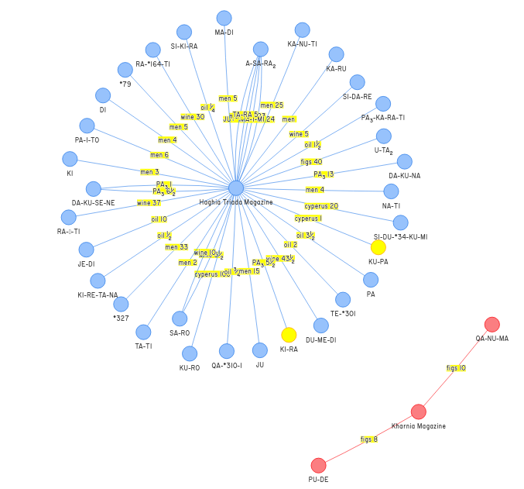

Figure 2: Single commodity transfer lists visualized. See https://lineara.xyz//network/?search=["Single-Commodity%20Transfer%20List"]

***Multiple-Commodity Inter-Entity Transfer List***

This structure builds on the ‘Transfer List’ by pre-pending an additional entity to the ‘Transfer List’ structure. We hypothesize that in this case the tablet is recording a transaction between two third parties rather than a transfer of goods to or from the administrative centre. As with the Transfer List this pattern can also accommodate the use of transaction signs in its heading.

|  |  |  |  |  |  |
| --- | --- | --- | --- | --- | --- |
| **Tablet Reading** | | **Pattern Level 1** | **Pattern Level 2** | | **Pattern Level 3** |
| KI-RI-TA₂ |  | Entity | | Entity | Multiple-Commodity Inter-Entity Transfer List |
| SA-RA₂ |  | Entity | | Transfer List |
| GRA | 10 | Commodity List | |
| OLE | 7 |
| NI | 1 |
| VIN | 1 |
| *23M | 3 |

Table 6: HT114a – a transfer list of multiple commodities between KI-RI-TA2 and SA-RA2.

The tablets we classify in this group are: *HT114a, HT116a, HT11b, HT120, HT125b, HT128a, HT16, HT20, HT28a, HT28b, HT31, HT33, HT34, HT35, HT43, HT90, HT91, HT96b, HT99a, KH7a, PE1, ZA11a, ZA11b.*

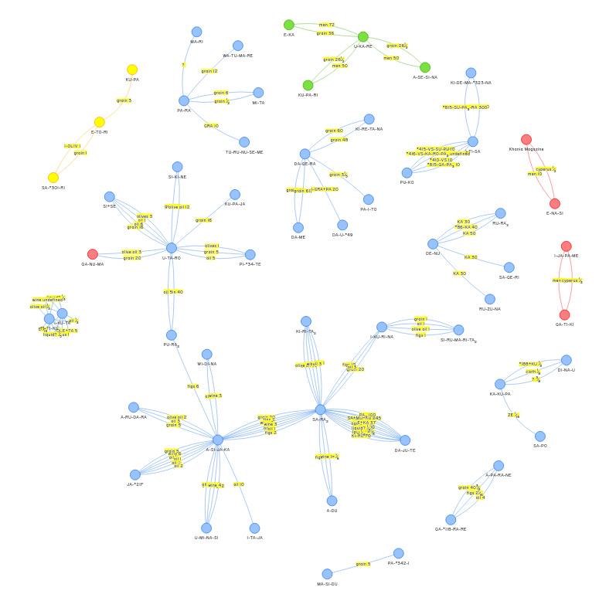

Figure 3: https://lineara.xyz/network/?search=["Multiple-Commodity%20Inter-Entity%20Transfer%20List"]

***Single-Commodity Inter-Entity Transfer List***

This is a syntactical pattern built on the ‘Entity List’ pattern rather than the ‘Commodity List’. It displays the same basic combinatorial pattern as the ‘Transfer List’ of a named entity, but with an ‘Entity List’ instead of a ‘Commodity List’. As with the other structures we have so far encountered it accommodates the use of a transaction sign in the headwords. For the purposes of our network map we propose that this type of list is recording a movement of some sort between the entity named in the head words and the entities named in the list. In a common form of the pattern there is no indication of the commodity that is being transferred between the entities.

|  |  |  |  |  |
| --- | --- | --- | --- | --- |
| **Tablet Reading** | | **Pattern Level 1** | **Pattern Level 2** | |
| QE-RA₂-U 𐄁 |  | Entity | | Single-Commodity Inter-Entity Transfer  List |
| KI-RO | 197 | Entity List | |
| ZU-SU | 70 |
| DI-DI-ZA-KE | 52 |
| KU-PA₃-NU | 109 |
| A-RA-NA-RE | 105 |

Table 7: HT1 – a transfer of an unspecified commodity between QE-RA2-U and 5 named entities.

*The tablets we classify in this group are: HT1, HT104, HT10a, HT10b, HT117a, HT122a, HT123+124b, HT126a, HT15, HT20, HT26a, HT85b, HT88, HT94b, HT95b, HT9b.*

There is a distinct variation in the pattern that accommodates a commodity in the head words. In such cases we hypothesize that the tablet is recording the movement of this named commodity.

|  |  |  |  |  |
| --- | --- | --- | --- | --- |
| **Tablet Reading** | | **Pattern Level 1** | **Pattern Level 2** | |
| KA-U-DE-TA |  | Entity | | Single-Commodity Inter-Entity Transfer  List |
| VIN |  | Commodity | |
| 𐄁 TE 𐄁 |  | Transaction Sign | |
| RE-ZA | 5[ ]¹⁄₂[ | Entity List | |
| TE-TU | 56 |
| TE-KI | 27 ¹⁄₂ |
| KU-ZU-NI | 18 |
| DA-SI-*118 | 19 |
| I-DU-NE-SI | 5 |
| KU-RO | 130 ¹⁄₂ |

Table 8: HT13 – a transfer of wine between KA-U-DE-TA and 6 named entities. KU-RO is assumed to represent a total.

|  |  |  |  |  |
| --- | --- | --- | --- | --- |
| **Tablet Reading** | | **Pattern Level 1** | **Pattern Level 2** | |
| *47-NU-RA-JA |  | Entity | | Single-Commodity Inter-Entity Transfer  List |
| 𐄁I𐄁 |  | Transaction Sign | |
| GRA+BOSm |  | Commodity | |
| RI-TA-MA-NU-WI | 2 | Entity List | |
| *301-U-RA |  | Entity | | Single-Commodity Inter-Entity Transfer  List |
| NA-*21F-NE-MI-NA | 1 | Entity List | |
| SE-KU-TU | ¹⁄₂ |
| PA-RA-NE | 1 |
| A-SE-JA | 𐝂𐝂𐝂𐝂 |
| KA-PO-RU | 1 |
| RI-SU-MA[ | [ ] |
| SU | 2 ¹⁄₅[ |

Table 9: HT115a – two transfers of quantities of GRA+BOSm. The first between *47-NU-RA-JA and RI-TA-MA-NU-WI. The second between *301-U-RA and 7 named entities.

The tablets we classify in this group are*:* ARKH2, HT102, HT115a, HT115b, HT122b, HT13, HT26a, HT6a, HT6b, HT7a, HT7b, HT85a, HT86a, HT86b, HT95a, HT9a, ZA10b, ZA15a, ZA5a, ZA8.

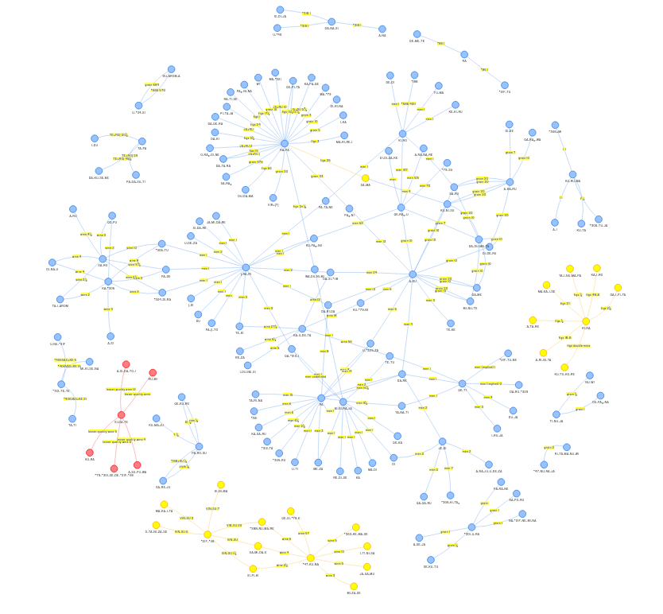

Figure 4: <https://lineara.xyz/network/?search>=["Single Unnamed Commodity Inter-Entity Transfer List","Single Named Commodity Inter-Entity Transfer List"]

**Complex Structures**

Tablets in this group display sufficient complexity to resist easy classification under any of our previous headings. This may be due to a difference in concerns from already classified tablets. For example HT87 and HT117a may list people by name and not reflect any transaction function (Younger). In both cases the tablet contain Entity Lists with whole numbers assigned, preceded by multiple head words.

HT88 contains a Single-Commodity Transfer list, a Commodity combined with an Entity List, and a Single-Commodity Inter-Entity Transfer List.

|  |  |  |  |  |
| --- | --- | --- | --- | --- |
| **Tablet Reading** | | **Pattern Level 1** | **Pattern Level 2** | |
| A-DU |  | Entity | | Single-Commodity Transfer list |
| VIR+KA | 20 | Commodity List | |
| RE-ZA | 6 | Entity List | |
| NI 𐄁 |  | Commodity | | Transfer List (?) |
| KI-KI-NA | 7 | Entity List | |
| KI-RO 𐄁 |  | Entity | | Single-Commodity Inter-Entity Transfer List |
| KU-PA₃-PA₃ | 1 | Entity List | |
| KA-JU | 1 |  | |
| KU-PA₃-NU | 1 |  | |
| PA-JA-RE | 1 |  | |
| SA-MA-RO | 1 |  | |
| DA-TA-RE | 1 |  | |
| KU-RO | 6 |  | |

Table 10: HT88

We see a similar structure to ‘NI𐄁 KI-KI-NA 7’ in HT15: ‘*188𐄁 KI-RO 400’. Since it is not common it may be a variation on the ‘Transfer List’, e.g. ‘KI-KI-NA𐄁 NI 7’. Also in HT103.

HT96a contains 4 head words. If the first three are to be considered separately then the text from SI-MI-TA to the dividing line may be read as a Single Commodity Transfer List.

TY2 may be a list of commodities or entities (commodities seems more likely). If the entries beginning with *309 are indeed commodities then the tablet consists of a Commodity List followed by a Transfer List (with PA-DA-RU).[4]

## 2. Constructing a Network Graph

In order to create a network graph that visualizes the transactions between proposed entities we chose a third-party javascript library called vis. This can be used to display an interactive network graph in a web browser. Vis requires us to build a database of nodes (entities) with transactions as the edges between the nodes. The most convenient way of doing this is to construct a file in JSON format for each tablet that identifies the proposed nodes in the graph and includes metadata identifying the commodities and values for each transaction between the nodes.[5] An example of what this looks like for the par of relatively simple ‘Transfer Lists’ given in HT121 is as follows:

{

    "name": "HT121",

    "transactions": [

        {

            "description": "sender",

            "transactionID": "HT121-1",

            "transliteratedWord": "Haghia Triada Magazine"

        },

        {

            "description": "sender",

            "transactionID": "HT121-2",

            "transliteratedWord": "Haghia Triada Magazine"

        }

    ],

    "words": [

        {

            "description": "recipient",

            "transactionID": "HT121-1",

            "transliteratedWord": "KI-RI-TA₂",

            "word": "𐘸𐘭𐘷"

        },

        {

            "commodityID": 1,

            "description": "commodity",

            "transactionID": "HT121-1",

            "transliteratedWord": "OLE+QE+DI",

            "word": "𐜘"

        },

        {

            "commodityID": 1,

            "description": "quantity",

            "transactionID": "HT121-1",

            "transliteratedWord": "10",

            "word": "𐄐"

        },

        {

            "description": "recipient",

            "transactionID": "HT121-2",

            "transliteratedWord": "SA-RA₂",

            "word": "𐘞𐘽"

        },

        {

            "commodityID": 1,

            "description": "commodity",

            "transactionID": "HT121-2",

            "transliteratedWord": "GRA",

            "word": "𐙉"

        },

        {

            "commodityID": 1,

            "description": "quantity",

            "transactionID": "HT121-2",

            "transliteratedWord": "5",

            "word": "𐄋"

        },

        {

            "commodityID": 2,

            "description": "commodity",

            "transactionID": "HT121-2",

            "transliteratedWord": "OLE",

            "word": "𐙖"

        },

        {

            "commodityID": 2,

            "description": "quantity",

            "transactionID": "HT121-2",

            "transliteratedWord": "4",

            "word": "𐄊"

        },

        {

            "commodityID": 3,

            "description": "commodity",

            "transactionID": "HT121-2",

            "transliteratedWord": "NI",

            "word": "𐘝"

        },

        {

            "commodityID": 3,

            "description": "quantity",

            "transactionID": "HT121-2",

            "transliteratedWord": "2",

            "word": "𐄈"

        },

        {

            "commodityID": 4,

            "description": "commodity",

            "transactionID": "HT121-2",

            "transliteratedWord": "VIN",

            "word": "𐙍"

        },

        {

            "commodityID": 4,

            "description": "quantity",

            "transactionID": "HT121-2",

            "transliteratedWord": "3",

            "word": "𐄉"

        },

        {

            "commodityID": 5,

            "description": "commodity",

            "transactionID": "HT121-2",

            "transliteratedWord": "*23M",

            "word": "𐘖"

        },

        {

            "commodityID": 5,

            "description": "quantity",

            "transactionID": "HT121-2",

            "transliteratedWord": "3",

            "word": "𐄉"

        }

    ]

}

For each transaction we designate ‘sender’ and ‘recipient’ nodes - these are convenience terms only since we are not presenting a directed graph and do not have a strong hypothesis on which direction the commodities are flowing in any given ‘Transfer List’. For each commodity and value that we propose is passing between the nodes we assign a unique transactionID. Each combination of commodityID and transactionID will constitute a unique edge between the two nodes associated with that transaction. In the above example there are 5 edges between the administrative centre (the ‘Haghia Triada Magazine’) and SA-RA₂.

Fortunately it was not necessary to construct these entries for every tablet by hand. We wrote a Python script that made an informed guess for the appropriate construction of the JSON record each tablet, based on our proposed classification.[6] Each entry was then reviewed and corrected as required, before being merged into a single file, transactions.js.[7]

When a user loads <https://lineara.xyz/network> the page constructs a full list of all nodes given in transactions.js and builds a network of edges that connect them. In order to help the user distinguish between the different geographies associated with the tablets, nodes for each find site are assigned a unique color. We also annotate each edge with its commodity and value.

To assist the user in exploring the graph we have made the nodes interactive. Clicking on a node will limit the displayed graph to just that node and other nodes connected to it. The user can in this way build up a graph of just the nodes and edges they are interested in.

The graph also has a search function. Searching can be done on tablet name, entity name, find site. Search terms are cumulative, again allowing the user to build up a cumulative picture of just the nodes that interest them.

We consider our interpretation of the tablets provisional, so it is important to allow the critical user view the source of any given relationship represented in the graph. For this reason, when a user hovers overs an edge in the graph we display the tablet the nodes and edge are sourced from with the relevant words in the tablet highlighted. This permits the user easily to assess if the relationship is a valid one according to their own interpretation of the tablet.

## 3. Observations on the Network Graph

As might be expected our graph is dominated by nodes from Haghia Triada (HT). Most prominent are transfers between the HT administrative centre (designated the ‘Haghia Triada Magazine’ in the graph) and other entities.

But we also observe a large tangle of connections (‘network edges’) between Haghia Triada nodes that do not involve the administrative centre. If our interpretation of the tablets is correct this indicates a high degree of economic activity between entities around the Haghia Triada centre. Some nodes are much more connected than others: SA-RA2, KA-RA, A-SI-JA-KA, A-DU are highly connected for example. This may indicate that these are entities more economically active than the others found in the tablets, but it may also suggest that they are not entities but words with a specific adminstrative meaning or function, such as transaction vocabulary. A-DU, for example, has been proposed as a word meaning ‘assessment’. Such considerations aside, what is striking from this part of the graph is how many HT nodes have more than one edge, in other words they are involved in more than one transaction with other nodes in the network.

But the purpose of this graph is not for me to make inferences about Minoan economic activity but to allow the reader to explore it for themselves and decide if it provides any useful insights. The basis for constructing the graph is inescapably provisional; the classification and interpretation of Linear A tablets is always a castle built on sand, and the system I’ve suggested here unquestionably has the limitation of assuming that the majority reflect relatively straightforward transactions. For this reason, the network graph is offered as a visualisation tool for the interested reader to aid the ongoing inquiry in Linear A studies, champion in particular by Younder and Schoep, into what the purpose of each tablet may have been rather than what the individual words on the tablet may have signified.

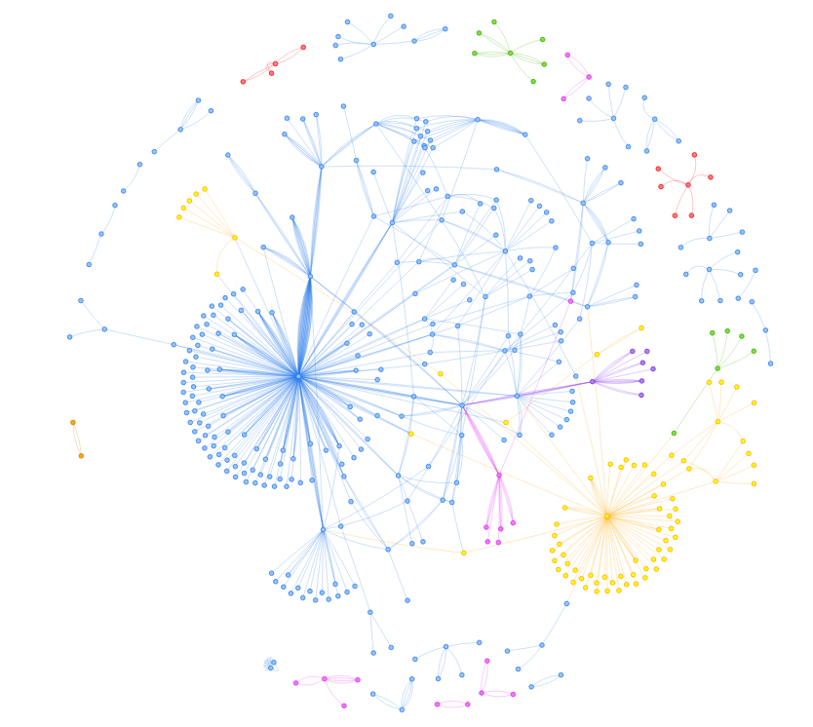

Figure 5: A view of the complete network graph. The user can use the mouse wheel to zoom in and out of the graph. Haghia Triada is in blue, Zakros in yellow, Kharnia in pink, Tylissos in purple, Arkhanes in green, Petras in red.

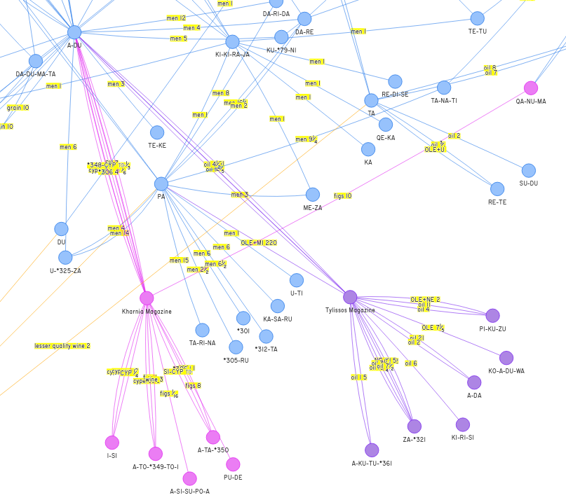

Figure 6: A detail from the graph showing the nodes that connect Haghia Triada with Tylissos and Kharnia.

1. Ilse Schoep, The Administration of Neopalatial Crete: A Critical Assessment of the Linear A Tablets and Their Role in the Administrative Process (Salamanca: Ediciones Universidad Salamanca).
2. R.Palmer, “Linear A Commodities: a Comparison of Resources”, Aegeum 12 (1995), p.133-155.
3. Schoep Ilse. The role of the Linear A tablets in Minoan administration. In: Ktèma : civilisations de l'Orient, de la Grèce et de Rome antiques, N°26, 2001. pp. 55-62;
4. The following tablets are too fragmentary to permit classification: ARKH4b, HT110b, HT137, HT139, HT140, HT154a, HT25b, HT26b, HT27a, HT3, HT38, HT45b, HT49a, HT50a, HT51a, HT60, HT62+73, HT69, HT82, HTZd157+156, KH12, KH15, KH21, KH25, KH26, KH54, KH55, KH58, KH6, KH60, KH61, KH63, KH73, KH75, KH76, KH8, KH84, KH91, KN2, KN28a, MA4a, MA6a, MA6c, PH3b, PH8a, PK3, THEZb5, THEtab.4, ZA12a, ZA12b, ZA18a, ZA1b, ZA26a, ZA4b.
5. https://github.com/mwenge/lineara.xyz/tree/master/network/transactions/final
6. https://github.com/mwenge/lineara.xyz/blob/master/network/transactions/030%20-%20Create%20Transactions.ipynb
7. https://github.com/mwenge/lineara.xyz/blob/master/network/transactions.js